

# Action Recognition Algorithm Research with G-sensor and Gyroscope

M.Sc. (Software Design and Development)

National University of Ireland, Galway

Discipline of Information Technology

College of Engineering & Informatics

Student: Jie Sun

Student Number: 16230972

Academic Supervisor: Dr. Frank Glavin



Table Of Contents

Action Recognition Algorithm Research with G-sensor and Gyroscope 1

Table Of Contents 4

Declaration 4

List Of Figures 4

List Of Tables 6

Glossary Of Abbreviations 7

Acknowledgements 8

Abstract 9

1 Introduction 10

1.1 Background Information 10

2 Accelerometer With Steps Algorithm 11

2.1 The Introduction And Working Principle Of An Accelerometer 11

2.1.1 What Is An Accelerometer 11

2.1.2 Working Principle Of An Accelerometer 11

2.1.3 How An Accelerometer Works In Mobile Phone. 12

2.2 The Principle Of Testing Steps 13

2.2.1 How An Accelerometer Works On Human Body 13

2.2.2 The Features Of One Steps 14

2.3 Key Algorithms Of Recording Steps 16

2.3.1 Peak Detection Algorithm 16

2.3.2 Transform Domain Algorithm 16

2.3.3 Threshold Filtering Algorithm 17

2.3.4 Pattern Recognition Algorithm 18

2.4 The Pedometer Program 19

2.4.1 The Program Operation 19

2.4.2 The Accuracy Of Results 20

3 Gyroscope With Balance Racing Game 21

3.1 The Introduction Of Gyroscope 21

3.1.1 What Is A Gyroscope 21

3.1.2 Working Principle Of A Gyroscope 22

3.1.3 The Relationship Between Gyroscope And Accelerometer 23

3.2 The Racing Game With Gyroscope 24

3.2.1 How A Gyroscope Works In iPhone 24

3.2.2 Get The Current Orientation Of Movement Of The Phone. 24

3.2.3 Calculating The Current Angle In Pitch Axis 26

How A Gyroscope Works For The Racing Game 26

3.2.4 26

4 A Glow Stick With Accelerometer And Gyroscope 30

4.1 Appearance And Function Description 30

4.1.1 A Normal Glow-Stick 30

4.1.2 A Multifunctional Glow-Stick 31

4.2 How And Why Need Accelerometer And Gyroscope 32

4.2.1 The New Action Recognition 32

4.3 Action Recognition Algorithms 38

4.3.1 Using Those Two Kinds Of Angle Restriction Together To Control Or Identify Those Three Actions 38

4.4 The Test Program of The Action Recognition 44

4.4.1 The Interface of The Program 44

4.4.2 Action Recognition Algorithms 45

5 Bibliography 47

# Table Of Contents

## Declaration

## List Of Figures

Figure 2.1:Working Principle Of A Capacitive Accelerometer. (Nisticò, 2013) 11

Figure 2.2: Accelerometer Theory & Design (Nisticò, 2013) 12

Figure 2.3: Three-Axis Accelerometer In A Phone (YingWen, 2014) 13

Figure 2.4: 3-Axis Digital Accelerometer (Zhao, 2008) 14

Figure 2.5:A Step, Stride and Heading Determination For The Pedestrian Navigation System 14

Figure 2.6:The Three Axes Data Of The Accelerometer From iPhone 15

Figure 2.7:The Total Accelerometer Data After Calculation 15

Figure 2.8:The Peak Data Of The Accelerometer 16

Figure 2.9:The Intervals Among The Peaks 17

Figure 2.10:The Threshold Figure 18

Figure 2.11:The Different Pattern Data 19

Figure 2.12:The Program Of Calculating The Steps 20

Figure 2.13:The Accuracies Of The Step Algorithms 21

Figure 3.1:Wili Commons. (Wilimedia, 2006) 22

Figure 3.2:Gyroscope Principles (Pigeon's nest, n.d.) 23

Figure 3.3: A Gyroscope Works In An Airplane (Mraz, 2014) 24

Figure 3.4: Gyroscope Sensor In A Phone (Kealy, 2017) 25

Figure 3.5: The Angular Velocities Of Three Axes Data Of Gyroscope 25

Figure 3.6: Racing Game In iPhone (H, 2010) 27

Figure 3.7: Gyro With Racing Game (H, 2010) 28

Figure 3.8:Racing Gyro Data Of Three Axes 28

Figure 3.9:The Pitch Angle Offset From The Racing Game 29

Figure 4.1: A Kind Of Glow Sticks 30

Figure 4.2: A Vocal Concert 31

Figure 4.3: Audiences Shake Glow Sticks 32

Figure 4.4:Scanning Rooms With An iPhone. (Przemek, 2014) 33

Figure 4.5:Spinning Angle After High-pass Algorithm 35

Figure 4.6: The Direction Of The Gravitational Acceleration Of An Object (CSDN Blogs, 2014) 35

Figure 4.7 The Inclination Of Each Axis With The Direction Of Gravity (CSDN Blogs, 2014) 36

Figure 4.8:Put The Phone Up 37

Figure 4.9:Gyro Data Changes 38

Figure 4.10: Shank The Phone In Action1 39

Figure 4.11:Spinning Angle Changes In Action 1 40

Figure 4.12: Angles With The Gravity Changes In Action1 40

Figure 4.13:Spinning Angle Changes In Action 2 41

Figure 4.14: Angles With The Gravity Changes In Action 2 42

Figure 4.15: Spinning Angle Changes In Action 3 43

Figure 4.16: Angles With The Gravity Changes In Action 3 43

Figure 4.17 Action Report Interface 45

Figure 4.18 Action 1 Gyro Data 46

Figure 4.19 : Action 1 Acceleration Data 46

Figure 4.20 Action 1 Calculation 47

## List Of Tables

Table 4.1:Spinning Angle Restrictions In Action 1 40

Table 4.2: Angles With The Gravity Restrictions In Action 1 41

Table 4.3:Spinning Angle Restrictions In Action 2 41

Table 4.4:Angles With The Gravity Restrictions In Action 2 42

Table 4.5: Spinning Angle Restrictions In Action 3 43

Table 4.6:Angles With The Gravity Restrictions In Action 3 43

## Glossary Of Abbreviations

|  |  |
| --- | --- |
| **Abbreviation** | **Full Title** |
| **AI** | **Artificial Intelligence** |
| **GPRS** | **General Packet Radio Service** |
| **Gyro** | **Gyroscope** |
| **G-sensor** | **Accelerometer** |
| **APP** | **Application** |

## Abstract

Nowadays, Artificial Intelligence (AI) has become more and more popular, and the action recognition algorithm is a very important part and researched by more and more experts. Exactly, the action recognition algorithm is not a strangle thing that has been used not only on a robot, but also in our daily lives, such as iPhone, iPad, smart watch and smart pen etc. In this thesis, we are going to study two devices, Accelerometer and Gyroscope, how they work and how they are used with some recognition algorithms, and the most important part is the last chapter which discuss a hypothesis which tries to use those two devices with some recognition algorithm to make sure a multiple function glow sticks.

## Acknowledgements

First and foremost, I would like to thank my supervisor, Dr. Frank Glavin for his continued support, especially for me, since I nearly did my internship in some company for more than half year in the second academic year. However, it is still going well due to Dr.Frank paying lots attention to me and checking the progress almost once a week, that I appreciate so much.

# Introduction

## Background Information

Nowadays, the rapid development of science and technology has brought lots of conveniences to human daily life and one kind of technologies, action recognition technique, starts to permeate every corner of our lives. Maybe you still haven’t noticed it yet, but exactly you have high possibility of using it before. There are some examples of the applications in our daily lives of this technique: healthy smart watch that helps us to recorde the steps every day we walk; robots that can simulate some actions of human; racing game that you just need to move your hands to play games. Absolutely, action recognition technique is not only just those, in this thesis, it shows a possibility to use the gyro and accelerometer to another field and create a new product, a multiple function glow-stick maybe it will appear in near future.

There two purposes for this thesis, one is to introduce what the gyroscope and accelerometer are and how they work and some basic application in our daily lives; the another is to put forward a hypothesis for some new product using those two devices and some basic algorithms. The author is really interested in this technology and hope to do something for helping someone who is also interested and wants to study to get a basic principle for those two devices.

The another one is the concept of new function glow stick can be proven and may appear in near future and this product can be used in some areas for people having some fun or any other functions. Something special for it is this glow stick has action recognition function and can shows different colors in some specific actions.

# Accelerometer With Steps Algorithm

## The Introduction And Working Principle Of An Accelerometer

### What Is An Accelerometer

Wikipedia explains: “An accelerometer is a device that measures proper acceleration. Proper acceleration, being the acceleration of a body in its own instantaneous rest frame, is not the same as coordinate acceleration, being the acceleration in a fixed coordinate system”. Exactly, an accelerometer is not hard to be understood and just need to know it is used to test the physical acceleration, which is taught in high school physics course and is the rate of change of velocity of an object.

### Working Principle Of An Accelerometer

As I mentioned before that an accelerometer is used to test the acceleration of an object. What is the acceleration here? Exactly, it is the change rate of the velocity of an object and can be described as the ‘a’ in formula: F=-kx=ma, we studied in middle or high school courses. (Nisticò, 2013)

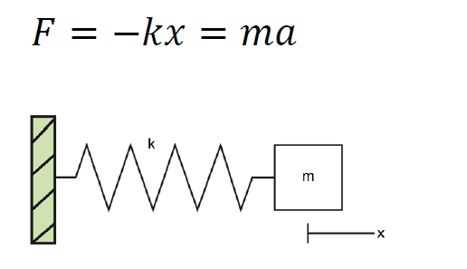

Figure 2‑1:Working Principle Of A Capacitive Accelerometer. (Nisticò, 2013)



Figure 2‑2: Accelerometer Theory & Design (Nisticò, 2013)

As Figure 2.2 above shows the inner structure of a kind of accelerometers, which be comprised of Seismic mass, a Damping element, a spring (Elastic element), External reference and Internal reference frame. When the vehicle is moved with an acceleration, the mass will move to another position, the spring will stretches and x and y, Internal reference and External reference, will change, so there is a relationship happened between the vehicle acceleration and the references of x and y.

In our daily life, the most popular type of accelerometer is the Three-Axis Acceleration Sensor in the market. Just as its name implies, the three-axis accelerometer does not only test one direction’s acceleration, but three directions’ accelerations: X, Y and Z.

### How An Accelerometer Works In Mobile Phone.

Here, we just use the three-axis accelerometer of an iPhone as an example to describe how an accelerometer works in an iPhone. As we mentioned before, a three -axis accelerometer is used to test three different directions’ acceleration. There are two figures (YingWen, 2014), which show three-dimensional axis and the acceleration of every axis can be tested by the accelerometer installed in the phone.

When an object is in static condition, it has only the gravitational acceleration in perpendicular direction with the ground. The two figures below show the accelerations of a phone in static condition, and it just prove that no matter the accelerometer put in which direction, in static condition that it only be affected by gravity.

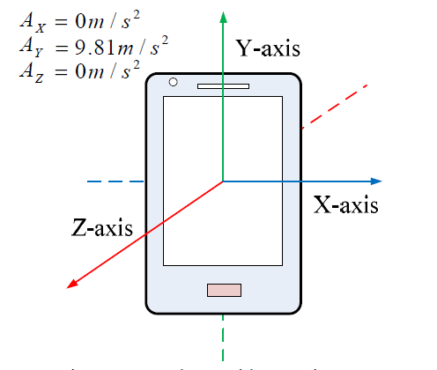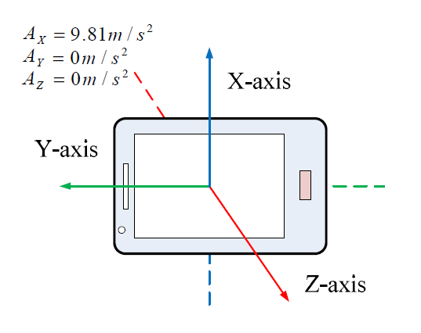

Figure 2‑3: Three-Axis Accelerometer In A Phone (YingWen, 2014)

And maybe some beginners will ask how to get the three axes data from an iPhone. Exactly, there are some APPs creating the function to catch the efficient data directly from the phone, which can get not only the data of accelerometer from the iPhone to email to your email box, but also Gyroscope data which will be discuss in next chapter and Magnetometer sensor.

## The Principle Of Testing Steps

### How An Accelerometer Works On Human Body

The figure below shows a pedestrian with an accelerometer. When a pedestrian is walking on the road, the accelerometer will divide the motion acceleration by three directions, Vertical Direction, Forward Direction and Side Direction, which can be also called: X, Y and Z Axis.

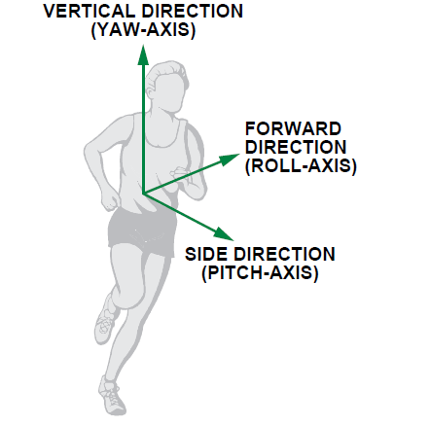

Figure 2‑4: 3-Axis Digital Accelerometer (Zhao, 2008)

### The Features Of One Steps

There is a swing phase showed in the Figure below ,which is a step period during people movement. Absolutely, there is a change process of speed of the leg movement during one step period, so we can catch the acceleration in three directions using the accelerometer.

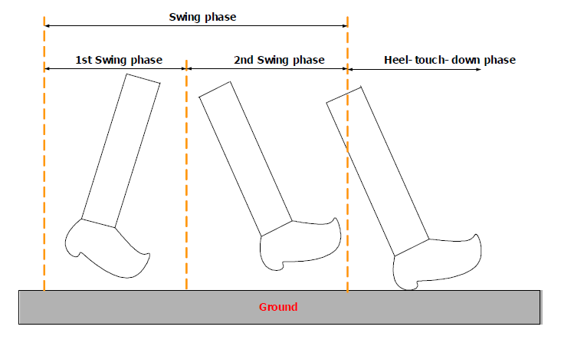

##### Figure 2‑5:A Step, Stride and Heading Determination For The Pedestrian Navigation System

Figure 2.6 below shows the typical three axes, x, y and z (matching vertical, forward and side acceleration) data of the accelerometer in my iPhone during walking, and what conclusion can be got from this picture, so no matter how the pedometer wears the phone, there is at least one axis data have sharply periodic changes (this picture shows the Y axis changing sharply).

Figure 2‑6:The Three Axes Data Of The Accelerometer From iPhone

Even the direction of the phone in the pocket is unpredictable, the general tends can be got. Normally, we can use the sum formula to get a diagram below picture. As a valid step must have only one peak value and one bottom value.

Figure 2‑7:The Total Accelerometer Data After Calculation

## Key Algorithms Of Recording Steps

### Peak Detection Algorithm

Four Basic Conditions can be used: (the frequency of the data caught in this chapter is in 50Hz)

|  |
| --- |
| 1.Current point is going down. (The Red Point in the following diagram)  2. The previous point is going up. (The Black Point) |
| 3. At least going up twice before coming to positive peak. (The pink lines). |
| 4. The value of the positive peak should be bigger than 1.5g |

And we can go on to understand this algorithm by referring to the following diagram.

Figure 2‑8:The Peak Data Of The Accelerometer

### Transform Domain Algorithm

One condition can be used to exclude invalid data.

1. The duration of two effective adjacent peaks must be longer than 0.2S and shorter than 2s. (Based on common sense)

Figure 2‑9:The Intervals Among The Peaks

We can see the two red peak values are invalid using this algorithm.

### Threshold Filtering Algorithm

Two Basic Conditions:

|  |
| --- |
| 1. The current peak value minus the last valley value must be bigger than the threshold. |
| 2. The Threshold is Dynamic and related with different walking patterns. There is one red peak datum being filtered. |

The following figure can be an example for this algorithm.

Figure 2‑10:The Threshold Figure

### Pattern Recognition Algorithm

One regulation is:

|  |
| --- |
| For examples:(the walking patterns)   1. Walking, phone in pocket. 2. Walking, phone in hands. 3. Walking, phone beside ear. 4. Running, phone in pocket.   In different patterns, you can see the distinction of the wave variation of accelerometer value from the picture on the right. The following diagram shows the difference between the pattern of walking with the phone in the pocket and the pattern of running with the phone in the pocket. |

Figure 2‑11:The Different Pattern Data

## The Pedometer Program

### The Program Operation

To run this program showed in follow picture, you can get the exact steps and the accuracy of steps calculation. How to use this program to calculate the steps, there are two procedures below should be done:

1. Fill out the path of excel file of Accelerometer data and the test frequency before click Running.
2. Fill in the exact count steps in the Exact Steps and click Calculating.

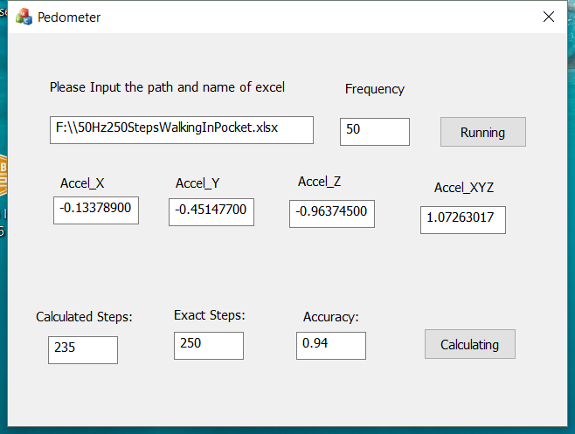

Figure 2‑12:The Program Of Calculating The Steps

### The Accuracy Of Results

We can get the accuracy of this program and this algorithm showed in following form. Of course, there is not the most accurate program or algorithm, and the purpose is to show the method for calculating steps.

|  |  |  |  |  |  |  |  |  |  |
| --- | --- | --- | --- | --- | --- | --- | --- | --- | --- |
| **Action pattern** | **Placement of Iphone** | **Height** | **Weight** | **Age** | **ground condition** | **Frequncy** | **Number of step (exactly)** | **number of steps (by program)** | **Accuracy** |
| **Walking** | in pocket of pants | 173cm | 60 Kilo | 28 | Flat | 25Hz | 150 | 250 | 0.6 |
| **Walking** | in pocket of pants | 173cm | 60 Kilo | 28 | Flat | 50Hz | 235 | 250 | 0.94 |
| **walking** | in hand(Natural Vertical) | 173cm | 60 Kilo | 28 | Flat | 50Hz | 243 | 258 | 0.94 |
| **Walking** | Put the Phone Beside Ear (to answer the phone call) | 173cm | 60 Kilo | 28 | Flat | 50Hz | 192 | 250 | 0.77 |
| **Running** | In pocket of Pants | 173cm | 60 Kilo | 28 | Flat | 50Hz | 258 | 250 | 0.97 |

.Figure 2‑13:The Accuracies Of The Step Algorithms



# Gyroscope With Balance Racing Game

## The Introduction Of Gyroscope

### What Is A Gyroscope

According to the [English Oxford Dictionary](https://en.oxforddictionaries.com/definition/gyroscope) (Oxforddictionaries, Mid 19th century), a Gyroscope is a "device consisting of a wheel or disc mounted so that it can spin rapidly about an axis which is itself free to alter in direction. The orientation of the axis is not affected by tilting of the mounting." Exactly, gyroscope is often used to detect the orientation that has similar function with compass. Nowadays the gyroscope becomes more and more popular and it has many applications such as used in inertial navigation systems and gyro compasses.

The most popular application is to be installed in the mobile phone. For example, it can work together with GPS in phones to help people navigate easier and more precise.

### Working Principle Of A Gyroscope

There are different kinds of gyroscopes, such as MEMS gyroscope、fibre optic gyroscope and the sensitive quantum gyroscope. Different types base on different principles of operation, and in this thesis, we just introduce the working principle of the most popular one used in iPhone.

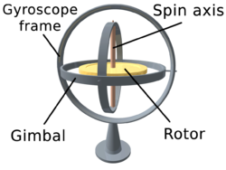

Figure 3‑1:Wili Commons. (Wilimedia, 2006)

As you can see the figure above, there is a Rotor which can spin freely 360 degrees around a Spin axis in a Gyroscope frame and a Gimbal. This is a basic frame of the Gyroscope and the angular velocity in each direction can be detected by the free rotation of the rotor.

There is another picture below, figure 3.2 (Pigeon's nest, n.d.), there is a clear space match between the gyroscope frame and coordinate graphs. Based on angular momentum the Rotor resists to changes in orientation, thereby allowing to measure the changes of the angles. The rotation or the angle changes in different directions or positions will affect a change of resistance of a gyroscope and in this way, we can calculate the angular velocity in those three-axes orientations, so this is a basic principle of how the gyroscope works.



Figure 3‑2:Gyroscope Principles (Pigeon's nest, n.d.)

### The Relationship Between Gyroscope And Accelerometer

At first, it is clear that two devices have different functions**:****Gyroscope senses the rotation, whereas another one is used to test the accelerometer. (put some reference)** The restriction of functions in two devices decides that they have to work together often.

There is an example to clarify the different functions of them. When an aircraft flies in the sky, the accelerometer can used to test the change of movement. For example, when an aircraft flies too fast in suddenly, the accelerometer can remind the pilot of the unsafe signal for the sudden change of the speed during flying forward. However, when the aircraft has some faults with an unsafe shake around itself, here the accelerometer cannot sense it, but the gyroscope can detect the any rotation of the aircraft to notice the pilot of the insecurity.

Through this example, we can further understand that they are totally different, but they can also make up for each other to achieve some functions.

## The Racing Game With Gyroscope

### How A Gyroscope Works In iPhone

Depending on the base of working principle of gyroscope, we continually discuss how a gyroscope works in an airplane, here, a figure below to show Gyroscope detecting angular velocity in three directions: Yaw, Roll and Pitch .

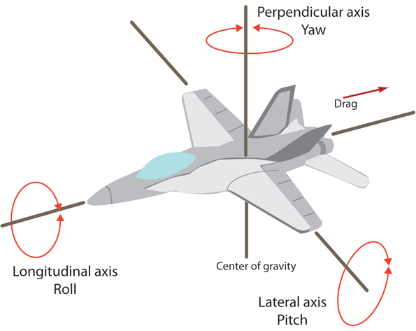

Figure 3‑3:  A Gyroscope Works In An Airplane (Mraz, 2014)

Absolutely, a gyroscope must be used to test the angular velocity or the orientation, so here we only need to solve two questions:

1. How to judge the current orientation of movement.
2. How to get the correct angle of the phone in every axis.

### Get The Current Orientation Of Movement Of The Phone.

There is a figure 3.4 below showing the gyroscope in a phone with the three direction axes: roll, pitch and yaw (x, y and z). When the phone moves around any axes, the angular velocity in each axis can be detected by the Gyro in the centre position.

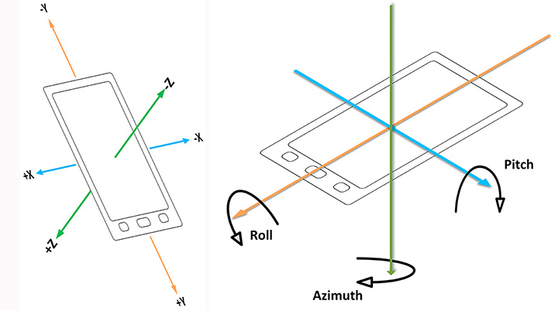

Figure 3‑4: Gyroscope Sensor In A Phone (Kealy, 2017)

Here, when we try to rotate the phone up and down several times only around Pitch (x) axis, it will produce a change of the angular velocity showed in the figure below. It is clear there is almost only one orientation data change happened on Pitch(x) axis. And what the information we can summarize is that any orientation the rotation happens it will cause the angular velocity on the corresponding axis.

Figure 3‑5: The Angular Velocities Of Three Axes Data Of Gyroscope

We can judge the orientation of current movement through the angular velocity, if there is the angular velocity in one axis, it means the phone is rotating or moving in that direction and if the value is positive, that means the phone is moving forward, vice versa.

### Calculating The Current Angle In Pitch Axis

Before for calculating the current angle, we must be clear for two functions of the basic mathematics here. I believe everyone has studied them during high school or university Physics and Math lessons.

One of them is θ = dθ/dt (Pieter-Jan, 2016), θ means the angular velocity, dθ means radian and dt is the time period, what this function doing is to describe how to using the angular velocity to get the angle change during a period.

Since we can get the angle in a specific period using the function above, in the next step we need to think how to get the absolute angle in any time.

Therefor another function should be mentioned here:

Θ(t) = ∫(0,1t)Θ(t)*dt ≈ Σ(o,t)Θ(t)*Ts (Pieter-Jan, 2016)

What function does is using the integral principle to integrate the angular velocity in all the period from time 0 ( t=0) to get the absolute angle. However, this is just a theoretical formula and there are some errors caused by two reasons. First one is because the sampling frequency is possible slower than the data changes and another cause is drift which causes the sensor reading not returning to 0 at the rest position, so to avoid those errors it is better to choose the high sampling frequency (100 Hz in Gyroscope used in this thesis). The next part, there is an example for explaining how to use those equations to calculate an exact angle.

### How A Gyroscope Works For The Racing Game

#### The Principle Of Racing Game



Figure 3‑6: Racing Game In iPhone (H, 2010)

Anybody may play the racing game in mobile phones or Pads and it is easy to get how to play it after trying several times. What you should do for operating this game is to control the horizontal balance offset for controlling the direction of the running of the car, in another word, just controlling the angle of the horizontal offset (or pitch axis in the picture below) can control the tilting direction of the car running. In a word, using the gyroscope to get the exact angle in Pitch (x) axis is the key point of this game.

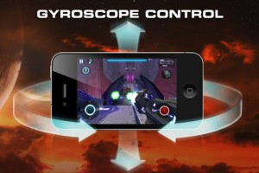

Figure 3‑7: Gyro With Racing Game (H, 2010)

#### Getting The Exact Angle Offset In Horizontal Level (Pitch axis)

Here using iPhone 6 as an example, 100 Hz sampling rate. This is ideal option of the frequency, but in different situations should be set in different frequencies for reducing the error rate.

There are gyro data caught from iPhone in the form below during playing a racing game. It simulates the action of playing race game through rotating the iPhone 6 around Pitch axis and we can ignore Roll and Yaw data, since we do not need to use them in this condition.

Figure 3‑8:Racing Gyro Data Of Three Axes

Here，from the picture above, we can use the integral principle mentioned above to collect the corresponding angle value below. What we can see from the form below is the phone are rotated about 50 degrees around Pitch axis. Obviously, there is a certain error because of the disturbance, and another way for calculating a more accurate angle will be discussed in next chapter for enhancing the accurate rate.

Figure 3‑9:The Pitch Angle Offset From The Racing Game

# A Glow Stick With Accelerometer And Gyroscope

From those three chapters above, we can know how to use Accelerometers and Gyroscopes to identify or detect some kinds of actions or postures, but it is possible to use it in a new action recognition and how a glow stick can show different colour lights in different actions, those will be discussed in this chapter.

## Appearance And Function Description

### A Normal Glow-Stick

How a normal glow stick works, everyone may have some experience for that. There is a picture below, when you turn on the switch on the handle, a glow stick will be lit in a specific colour.

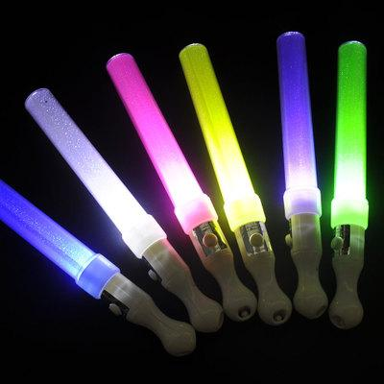

Figure 4‑1: A Kind Of Glow Sticks

There is no doubt that it is very gorgeous in a concert when the countless light sticks come on.



Figure 4‑2: A Vocal Concert

### A Multifunctional Glow-Stick

What kinds of new functions can be created for a glow stick, absolutely it is related with action recognition algorithm.

You can imagine if the light sticks moved in different directions will show different colours of light, it will be a very interesting idea. For example, when you shake the light sticks in perpendicular to the body, the glow stick will display the blue colour, and in the parallel plane to body, the glow stick will show the yellow colour, or in a round way above your body, the glow stick will show the red colour.

The automatic action or posture recognition is the key point for this function, and it is what have been mentioned above.

On the other hand, not only the colors of light can be controlled by different postures, but also the accelerometer and gyroscope can be used to adjust the brightness of lights.



Figure 4‑3: Audiences Shake Glow Sticks

## How and Why Need Accelerometer And Gyroscope

There are two functions mentioned above, which should be made sure in multifunctional glow sticks, and those functions are both relative with action recognition algorithm and acceleration.

### The Gestures Recognition

At First, function 1, shaking in different directions the glow sticks will display different colors of light. There are two kinds of movements or gestures those should be identified by the sticks, here the accelerometer and gyroscope can be used to analyze or recognize those movements; at same time, recording the times of shaking.

Action 1: shaking sticks in perpendicular to the body, the stick should display blue color. In detail,

Action 2: shaking in the parallel plane to body, the glow stick should show the yellow colour.

#### Accelerometer and Gyroscope in the iPhone 6

How the accelerometer and Gyroscope work in iPhone 6, which have mentioned in last two chapters. In the last charter, we already got that Gyroscope senses the rotation, whereas another is used to gain acceleration. And there is a picture below showing what exactly those two sensors test, Gyro tests the spinning angle and Accelerometer tests the angles in three directions relative with the gravity. Here, we use the iPhone to simulate a multifunctional glow-stick and setting the screen of the iPhone 6 is parallel with my body and faces forward. The figure below shows the x, y and z axes of Accelerometer and Pitch, roll and yaw of Gyroscope in iPhone 6.

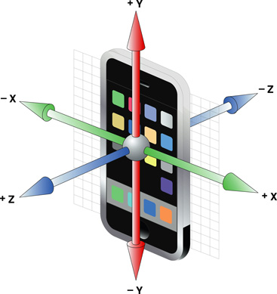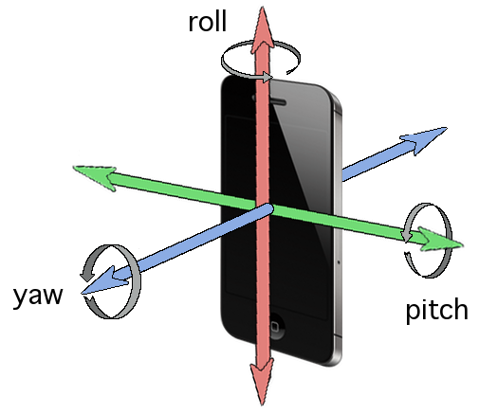

Figure 4‑4: Scanning Rooms With An iPhone. (Przemek, 2014)

#### Using Accelerometer and Gyroscope For The Angle Restrictions.

For those three actions recognition, exactly just only using the accelerometer can calculate an enough precise angle in three directions relative with the gravity. However, it is not enough for totally identifying those three actions, since sometimes the glow stick may rotate by itself, this cannot be tested by an accelerometer. In a word, the key point is to make sure the restrictions or standards for controlling an exact range of the angle changes in different directions, so at first we need to research how to use those two devices calculate the useful angles.

The last chapter mentions only using gyroscope to calculate the angle of the rotation around pitch axis in Racing Game. However, the angle calculated in this way is inaccurate, there is an algorithm which can be used to increase the accuracy.

#### Using Complementary Filter Algorithm to Eliminate Drift of Gyro.

What is Complementary Filter algorithm it can be searched in lots of websites and it is easy to understand. Since the two devices reflect oppositely in long term and short term running, for example, when Gyro runs for a long time, the drift will increase and at the same time the accuracy of angle calculating will decrease. Here, we can use Complementary Filter algorithm to merge the acceleration value with gyroscope value, which can reduce the drifting error. There is a formula for merging the two kinds of values and with a diagram showing the function of the Merging Algorithm.

Mgyro = K1 * Cgyro * Dt + K2 * Caccel;

Rgyro: the angular velocity after merging algorithm.

Cgyro: the real-time angular velocity.

Dt: Using to integrate the angle in a period.

Caccel: the real-time acceleration.

K1: here is 0.98.

K2: here is 0.02.

The function aims to remove the noise from accelerometer and eliminate the drift of Gyro, and there are two figures below showing the difference between the change of the spinning angle without using Complementary Filter algorithm in first figure and the change of the spinning angle after using Complementary Filter in the second figure. It is absolutely that using Complementary Filter Algorithm can almost eliminate the drift of Gyroscope data.

Figure 4‑5:The angle change putting the phone on the flat table

Figure 4‑6: Removing drift after Complementary Filter

#### Calculating A Slant Angle The By Accelerometer

At first, it uses the Accelerometer to calculate the angle of action 1: shaking the sticks in perpendicular to the body. We can imagine that when the glow stick is shaken in perpendicular direction with the body, nearly only the acceleration of Z axis acceleration will change during the shaking period.

How can we calculate the angle value by only accelerometer?

We should use the gravity during this process. Firstly let us see a figure below, imagine that is a phone put on the horizontal desk and the g means gravitational acceleration which is g=9.80665 m/s^2.

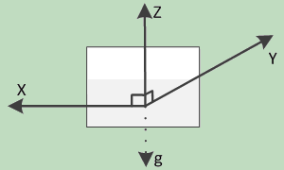

Figure 4‑7: The Direction Of The Gravitational Acceleration Of An Object (CSDN Blogs, 2014)

When the position changes like the picture below, and what information we can get is that the acceleration of X , Y and Z are Ax, Ay and Az respectively, and the value of radian: α1 、β1 、γ1 are the angles between X, Y and Z with horizontal line respectively and absolutely α 、β 、γ are the angles between X,Y and Z with g line: α = 90°- α1， β = 90°- β1 ， γ = 90°- γ1. We can get: Ax = gcosα， Ay = gcosβ ， Az = gcosγ and changing a formula to Ax = gcosα = gcos( 90°- α1) =gsinα1 and also Ay = gsinβ1 ， Az = gsin γ1.

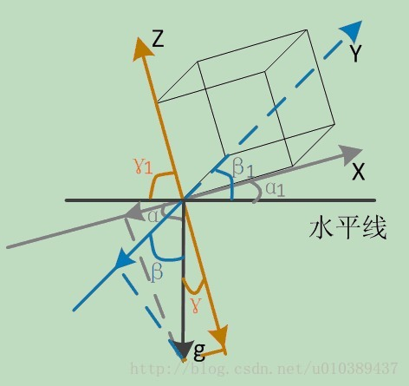

Figure 4‑8 The Inclination Of Each Axis With The Direction Of Gravity (CSDN Blogs, 2014)

Following the picture below and using Pythagorean proposition, we can get g*g = Ax*Ax + gcosα1*gcosα1, so other equations can be got using Trigonometric function theorem at same time: gcosα1 = sqrt(g*g - Ax*Ax) ，gcosβ1 =sqrt(g*g - Ay*Ay )，gcosγ1 =sqrt(g*g - Az*Az )). There is another equation got by  [principle](C:/Users/sunjie/AppData/Local/Youdao/Dict/Application/7.5.2.0/resultui/dict/?keyword=principle)[of](C:/Users/sunjie/AppData/Local/Youdao/Dict/Application/7.5.2.0/resultui/dict/?keyword=of)[equilibrium](C:/Users/sunjie/AppData/Local/Youdao/Dict/Application/7.5.2.0/resultui/dict/?keyword=equilibrium): Ax*Ax + Ay*Ay + Az*Az = g*g. (CSDN Blogs, 2014)

Here, using the equations we already got: sinα1 = Ax/g， cosα1 = sqrt(g*g - Ax*Ax) / g. And another changing equation is tanα1 =  Ax / sqrt(Ay*Ay + Az*Az) . In the same way, we can get   tanβ1 =  Ay / sqrt(Ax*Ax + Az*Az) ，tanγ1 =  Az / sqrt(Ax*Ax +Ay*Ay)。

The Radian respectively:

α1 = arctan(Ax / sqrt(Ay*Ay + Az*Az))

β1= arctan(Ay / sqrt(Ax*Ax + Az*Az))

γ1= arctan(Az / sqrt(Ax*Ax +Ay*Ay))

And using Radian = θπR/180 formula to get the real angle value: (CSDN Blogs, 2014)

θx = α1*180/π = [arctan(Ax / sqrt(Ay*Ay + Az*Az))] *180/π

θy =β1*180/π = [arctan(Ay / sqrt(Ax*Ax+Az*Az))]*180/π

θz =γ1*180/π = [arctan( Az / sqrt(Ax*Ax +Ay*Ay))]*180/π

Using the angle calculation formula, we can get a diagram below, horizontal ordinate is time that the unit is 0.01 s and vertical ordinate is the angle the unit is one degree, shows an iPhone is vertically put up from a desk. The inclination changes below in X, Y and Z axes, Y axis changes from 0° to -90° and Z axis changes oppositely from -90° to 0°，and absolutely the X almost does not change since the X axis is always parallel with the desk level.

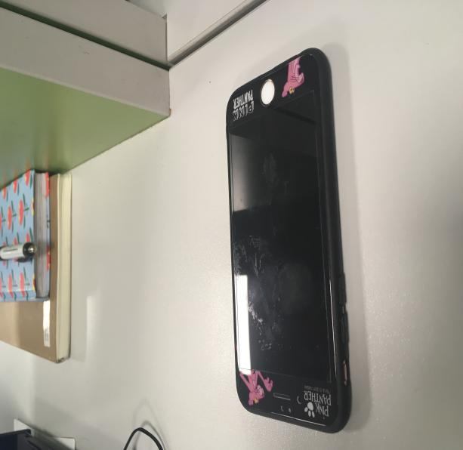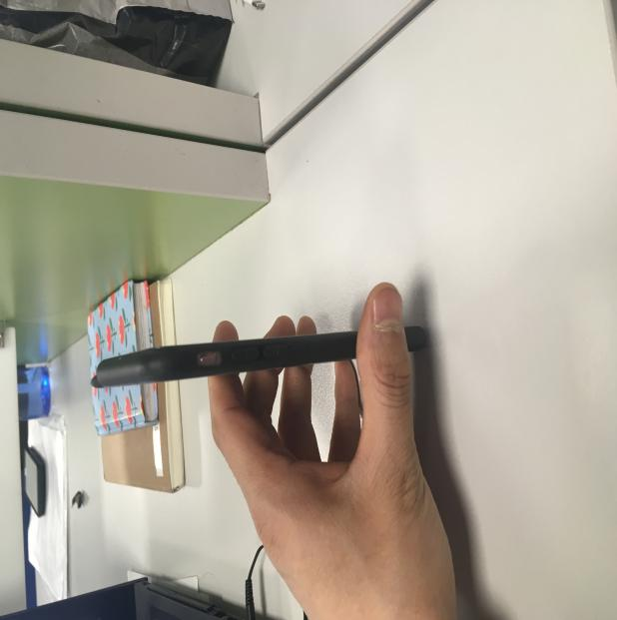

Figure 4‑9: Put The Phone Up

Figure 4‑10: Testing the change of the inclination when puttingc the phone up vertically

This angle value calculated by the raw data from accelerometer can be achieved through a piece of code below, Accel.Daccel_x, Accel.Daccel_y and Accel.Daccel_z are raw data caught from accelerometer and Accel.A_angle_x, Accel.A_angle_y and Accel.A_angle_z are the inclination angles with X, Y and Z axes respectively.

#define PI 3.14159265358979323846

double Sqrt_x = sqrt(Accel.Daccel_y * Accel.Daccel_y +Accel.Daccel_z * Accel.Daccel_z);

double Sqrt_y = sqrt(Accel.Daccel_x * Accel.Daccel_x +Accel.Daccel_z * Accel.Daccel_z);

double Sqrt_z = sqrt(Accel.Daccel_x * Accel.Daccel_x +Accel.Daccel_y * Accel.Daccel_y);

Accel.A_angle_x = (atan(Accel.Daccel_x / Sqrt_x) * 180) / PI;

Accel.A_angle_y = (atan(Accel.Daccel_y / Sqrt_y) * 180) / PI;

Accel.A_angle_z = (atan(Accel.Daccel_z / Sqrt_z) * 180) / PI;

## Action Recognition Algorithms

### Using Those Two Kinds Of Angle Restriction Together to Control or Identify Those Two Gestures

Basing on the last two sections, we can get the spinning angle and the inclination angle in three axes. In this section, first of all, it is to analyze the changes of the angles during a movement to find the regulations; and then, the next step is to make the restriction conditions of the change scope of those two kinds of angles.

There are two ranges of self-spinning angle and inclination angle from gyro and accelerometer, which be used together to identify two gestures. For example, the action1, when you rotate the glow sticks in three axes over the range tested by Gyro, it will be judged as a wrong action or not action1 even the inclination can meet the standards. On the other hand, when you shake the glow stick in a very small angle change range tested by accelerometer, it cannot be identified since the angle change does not meet the standards.

#### The Period of Data Collection

The testing frequency is always 100 Hz during collecting data, which means the collection period is 0.01s, so the unit of the horizontal ordinate is 0.01s in the figures of the data of the spinning angle or inclination angle in three axes.

#### Collecting Data and Making Standards

There is an example already mentioned in 4.2 chapter, when put the phone up from the desk level, the Z-axis angle increases when Y-axis decreases. Using this principle can make a set of algorithms to identify gestures and also count the times of the gesture happened, since there are some differences of the tendency of the angle change between those two gestures. Let illustrate one by one:

Gesture 1: Shake the sticks in perpendicular to the body, the stick should display blue color. Holding the phone makes the screen facing the same direction with you and shakes forward and behind.

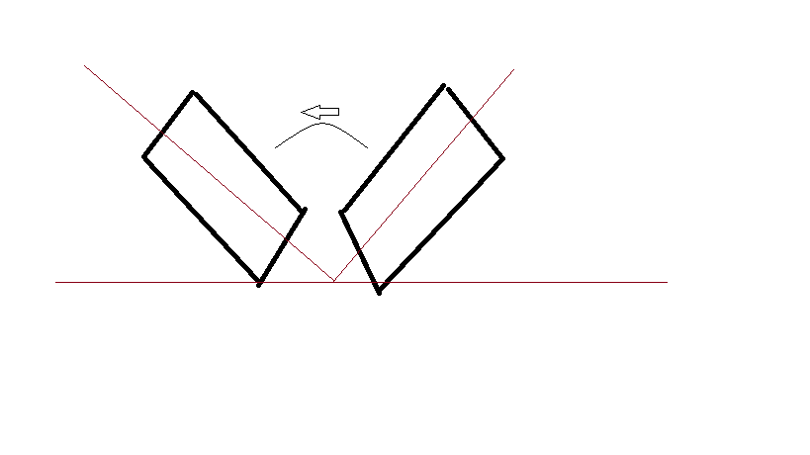

Figure 4‑11: Shank The Phone In Gesture1

There are two basic conditions to judge a valid gesture 1.

Condition 1: First is to analyze the self-rotation angle change to make threshold values of restrictions in three axes which are defined in Table 1 below. When the values of self-rotation angle in three directions can meet the threshold values, it means the data satisfy this condition.

Figure 4‑12: Spinning Angle Changes in Gesture 1

Table 4.1: Spinning Angle Restrictions in Gesture 1

|  |  |  |
| --- | --- | --- |
| Gyro testing angle | Minimum | Maximum |
| X-axis Spinning Angle | -150° | 150° |
| Y-aixs Spinning Angle | -60° | 60° |
| Z-aixs Spining Angle | -60° | 60° |

The piece of code below realize this a judgement.

action_123[0].gyro_x[0] and action_123[0].gyro_x[1] represent the threshold data of spinning angle with X-axis.

action_123[0].gyro_y[0] and action_123[0].gyro_y[1] represent the threshold data of spinning angle with Y-axis.

action_123[0].gyro_z[0] and action_123[0].gyro_z[1] represent the threshold data of spinning angle with Z-axis.

if (Gyro.G_angle_x > action_123[0].gyro_x[1] || Gyro.G_angle_x < action_123[0].gyro_x[0])

continue;

if (Gyro.G_angle_y > action_123[0].gyro_y[1] || Gyro.G_angle_y < action_123[0].gyro_y[0])

continue;

if (Gyro.G_angle_z > action_123[0].gyro_z[1] || Gyro.G_angle_z < action_123[0].gyro_z[0])

continue;

Condition 2: Restricting a range of the change of inclination angles with three direction axes, which can be seen in Table 4.2 below, when the three direction data can all meet the standards, which means those data are available data.

Figure 4‑13: The Inclination angle change in Gesture 1

Table 4.2: Angles With The Gravity Restrictions In Action 1

|  |  |  |
| --- | --- | --- |
| Accelerometer Testing | Valid Range | Regulation |
| Inclination – Z-axis  (Centre axis) | < -60°or  >62° | For Gesture 1, first and foremost ,the inclination with Z axis should be in the valid range |
| Inclination – X-axis | -15°to  5° | And then, control the inclination swith X axis. |
| Inclination – Y-axis | -10°to  13° | Finally, control the inclination with Z axis. |

There is a piece of code below realizes the judgement of the threshold data of the inclination in three axes. When i == 0, which means here using the threshold data of gesture 1, and this code if (Accel.A_angle_z < action_123[i].accel_z[0] || Accel.A_angle_z >action_123[i].accel_z[1]) is used to restrict the inclination angle in Z-axis.

if (i == 0)

{

if (Accel.A_angle_z < action_123[i].accel_z[0] || Accel.A_angle_z >action_123[i].accel_z[1])

if ((Accel.A_angle_y >action_123[i].accel_y[0] && Accel.A_angle_y< action_123[i].accel_y[1]))

if (Accel.A_angle_x > action_123[i].accel_x[0] && Accel.A_angle_x < action_123[i].accel_x[1])

flag[i] = true;

}

Gesture 2: shaking in the parallel plane to body, the glow stick should show the yellow colour.

Figure 4‑14: Spinning Angle Changes In Action 2

Table 4.3: Spinning Angle Restrictions In Action 2

|  |  |  |
| --- | --- | --- |
| Gyro testing angle | Minimum | Maximum |
| X-axis Spinning Angle | -50° | 50° |
| Y-aixs Spinning Angle | -50° | 50° |
| Z-aixs Spining Angle | -150° | 150° |

action_123[1].gyro_x[0] and action_123[1].gyro_x[1] represent the threshold data of spinning angle with X-axis.

action_123[1].gyro_y[0] and action_123[1].gyro_y[1] represent the threshold data of spinning angle with Y-axis.

action_123[1].gyro_z[0] and action_123[1].gyro_z[1] represent the threshold data of spinning angle with Z-axis.

if (Gyro.G_angle_x > action_123[0].gyro_x[1] || Gyro.G_angle_x < action_123[0].gyro_x[0])

continue;

if (Gyro.G_angle_y > action_123[0].gyro_y[1] || Gyro.G_angle_y < action_123[0].gyro_y[0])

continue;

if (Gyro.G_angle_z > action_123[0].gyro_z[1] || Gyro.G_angle_z < action_123[0].gyro_z[0])

continue;

Figure 4‑15: The Change of Inclination Angles in Gesture 2

Table 4.4: The Range of the Inclination Angle in Gesture 2

|  |  |
| --- | --- |
| Accelerometer Testing | Valid Range |
| Inclination – X-axis (Centre axis) | <-63°or >63° |
| Inclination – Y-axis | -10°to 30° |
| Inclination – Z-axis | -10°to 30° |

There is a piece of code below realizes this judgement of the inclination angle with three-axes. Here, firstly this line of code : if (Accel.A_angle_x < action_123[i].accel_x[0] || Accel.A_angle_x >action_123[i].accel_x[1]), it judges the inclination angle of X-axis as an initial condition, and then just the inclinations of Y-aixs and Z-axis, the same with judging gesture 1.

if (i == 1) {

if (Accel.A_angle_x < action_123[i].accel_x[0] || Accel.A_angle_x >action_123[i].accel_x[1])

if (Accel.A_angle_y > action_123[i].accel_y[0] && Accel.A_angle_y < action_123[i].accel_y[1])

if (Accel.A_angle_z > action_123[i].accel_z[0] && Accel.A_angle_z < action_123[i].accel_z[1])

flag[i] = true;

}



In code, defining those threshold values in a structure below:

struct Action_angle_strict action_123[2] = {

{ -30,30,-10,10,-10,10,-15,15,-10,13,-63,63 }, // action1 control Z-axis

{ -10, 10, -10, 10, -30, 30, -63, 63, -10,30, -10, 30 }, // action2 X-aixs

};



#### Validating the Collection Data

After judging the data validity through the threshold values, there is other two algorithms to validate whether it is a valid gesture or not.

First: a valid gesture happened should be there are more than 4 continuous valid data of the inclination angle meet the standards; in this way, it can avoid some individual abnormal data affecting the result.

Second: In one time can only one gesture happen and there must be a module change, which means the data of Inclination angle must change from invalid range to an invalid range to prove this is a movement, not just a static condition.

There is a piece of code below realizing the function, for example. aflag.last_times[0] Gesture 1 flag variable and aflag.last_times[1] is Gesture 2 flag variable ,when there is a specific gesture happened it will become 1 from 0, and aflag.previous_time means how many times the data continually meet the condition, and act is a flag for marking a gesture happens or not, if act

== 1 means there is a correct gesture caught.

if (aflag.last_times[1] != 0)

{

aflag.last_times[0] = 0;

aflag.last_times[1] = 0;

aflag.previous_time = 0;

act = 0;

}

else {

if (aflag.previous_time == 4)

aflag.last_times[0]++;

aflag.previous_time++;

if (aflag.last_times[0] == 1) {

aflag.last_times[0] = 0;

act = 1;

}

else {

act = 0;

}

}

## The Test Program of The Action Recognition

### The Interface of The Program

The program interface below can run two files, Acceleration file and Gyroscope file from iPhone, to calculate how many times those three actions happens, so in this way, it can totally show the action recognition algorithm works and prove those kinds of products which will be created in near future market.

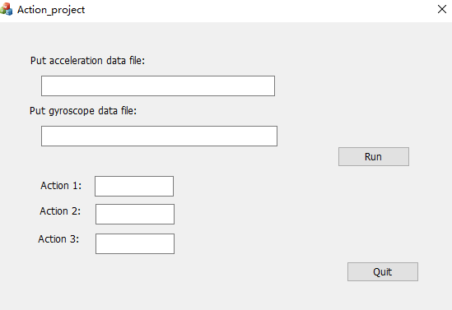

Figure 4‑18 Action Report Interface

### Action Recognition Algorithms

Action 1 algorithm: Doing action 1 exact 25 times, get the data below.

Figure 4‑19 Action 1 Gyro Data

Figure 4‑20 : Action 1 Acceleration Data

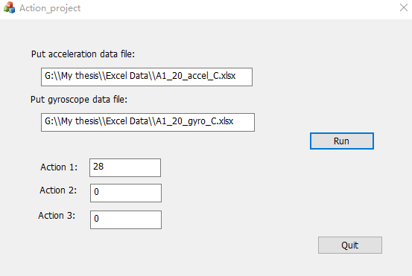

Figure 4‑21 Action 1 Calculation Result

Two Algorithms for action1;

Action judge algorithm:

There are some conditions it must meet to prove getting a correct action.

|  |  |
| --- | --- |
| 1. Z get an position which meet the requirements | Angle Z must be bigger than 55 or less than -55 |
| 2. And then Y must be in -20 to 20 | Angle Y must be bigger than -20 and less 20 |
| 3. X is a minor condition to control the movement. | Angle X must be bigger than -20 and less 20 |

Action mode algorithm:

If it is in a static condition, it should not be recorded as an action.

# Bibliography

CSDN Blogs. (2014, 08 13). *Accelerometer calculting the angles*. Retrieved from CSDN: https://blog.csdn.net/u010389437/article/details/38541561

H, V. (2010, 12 14). *Gyroscope apps and games*. Retrieved from Phonearena: https://www.phonearena.com/news/Gyroscope-apps-and-games_id15299

Mraz, S. (2014, 06 12). *What’s the Difference Between Pitch, Roll, and Yaw?* Retrieved from MachineDesign: http://www.machinedesign.com/engineering-essentials/what-s-difference-between-pitch-roll-and-yaw

Nisticò, A. (2013). *Working principle of a capacitive accelerometer.* Retrieved from Working principle of a capacitive accelerometer: http://engineering-sciences.uniroma2.it/MENU/DOC/TESI/2013/2013_tesi%20NISTICO%20Andrea.pdf

Oxforddictionaries. (Mid 19th century). *gyroscope definition*. Retrieved from oxforddictionaries: https://en.oxforddictionaries.com/definition/gyroscope

Pieter-Jan. (2016, 9 6). *Getting the angular position from gyroscope data*. Retrieved from http://www.pieter-jan.com/node/7: http://www.pieter-jan.com/node/7

Pigeon's nest. (n.d.). *Gyroscope*. Retrieved from Pigeonsnest: http://pigeonsnest.co.uk/stuff/howards-stuff/gyro/gyro.html

Przemek. (2014, 11 27). *Scanning rooms with an iPhone*. Retrieved from nomtek: https://www.nomtek.com/scanning-rooms-with-an-iphone/

Wilimedia. (2006, Oct 4). *3D Gyroscope.png*. Retrieved from Wilimedia: https://commons.wikimedia.org/wiki/File:3D_Gyroscope.png

YingWen, B. (2014). *http://ieeexplore.ieee.org/document/6901041/.* Retrieved from ieeexplore.ieee.org: http://ieeexplore.ieee.org/document/6901041/

Zhao, N. (2008). *Understanding the Model.* Retrieved from Analog dialogue: http://www.analog.com/en/analog-dialogue/articles/pedometer-design-3-axis-digital-acceler.html

# 